Budget Rent A Car 
of British Columbia

Global Information System

Customer Profile Business Design

Version 2.00

Note: The information contained in this document is confidential and may not be disclosed to any parties outside of Budget Rent a Car of British Columbia without written consent by one of its officers.
Copyright (C) 2000 Budget Rent a Car of British Columbia

Table of Contents
1. Business Design 1
1.1. Customer Profile 1
1.1.1. Process Description 1
1.1.1.1. Corporate Customers 1
1.1.1.2. Direct Bill Customers 1
1.1.1.3. Referral Companies 1
1.1.1.4. Individual Customers 2
1.1.2. Screens 3
1.1.2.1. Organization Screen 3
1.1.2.1.1. General Tab 5
1.1.2.1.2. Referrals Tab 8
1.1.2.2. Organization Search Results Dialog 11
1.1.2.3. Customer Screen 12
1.1.2.3.1. Renter Information 16
1.1.2.3.2. Rental History Tab 17
1.1.2.4. Customer Search Results Dialog 18
1.1.3. Reports 19
1.1.3.1. Do Not Rent List 19
1.1.3.2. Frequent Renter List 19
1.1.3.3. Referral Organizations by Organization Type 19
1.1.4. Background Processes 19
1.1.5. Test Scenario List 20
1.1.6. Controls & Audit Trails 21
1.1.7. Security Requirements 22
1.1.8. Business Transaction Volumes 23
1.1.9. Tables without Maintenance Screens 23
1.1.10. System Values Table Entries 23
1.1.11. Data Model 24
2. Revision History 25
2.1. Version 2.00 25

Business Design

Customer Profile

Process Description
Budget BC has four groups, corporate customers, direct bill customers, referral companies and individual customers, all of which are regarded as customers. It is possible for a customer to be both a corporate or direct bill customer and a referral company. GIS supports all these types of customer, but the only functionality provided for direct bill customers is that provided for corporate customers.

Corporate Customers
These are organizations that have one or more negotiated rates with Budget either at a national and/or local level. The organization may be a company, travel agent consortium, or a convention. All employees of the respective company, clients of the travel agent consortia or attendees of the convention may use the negotiated rate when renting a vehicle from Budget BC. Companies may have multiple rates assigned to them.
GIS provides the following facilities for corporate customers:
- A screen for maintaining organization information.
- A search facility for organizations.

Direct Bill Customers
Phase one of GIS will not provide facilities for direct bill customers beyond those provided for corporate customers.

Referral Companies
These include travel agents, and other organizations with whom Budget BC has an agreement to pay commissions on rentals where the organization referred the renter to Budget BC. The other organizations include tour companies, hotels, bodyshops, tourist information centres, property management companies (e.g. in Whistler).
GIS provides the same facilities for referral companies as it does for corporate customers, along with the following:
- A tab for referral information on the screen used for maintaining organization information.
- A Referral Organizations by Organization Type report.

Individual Customers
This group includes all renters (the person who signs the rental contract) and additional drivers. The renter may or may not have a BCN (Budget Customer Number). Customer profile information will not be maintained for customers who simply buy sales accessories (i.e. no vehicle rental involved). Customer profile information will be maintained for individuals who have never been a renter or an additional driver, but who are on Budget’s “Do Not Rent” list.
GIS provides the following facilities for individual customers:
- A screen for maintaining customer information.
- A search facility for customers.
- A Do Not Rent List (addressed in reporting)
- A Frequent Renter List (addressed in reporting)

Screens

Organization Screen
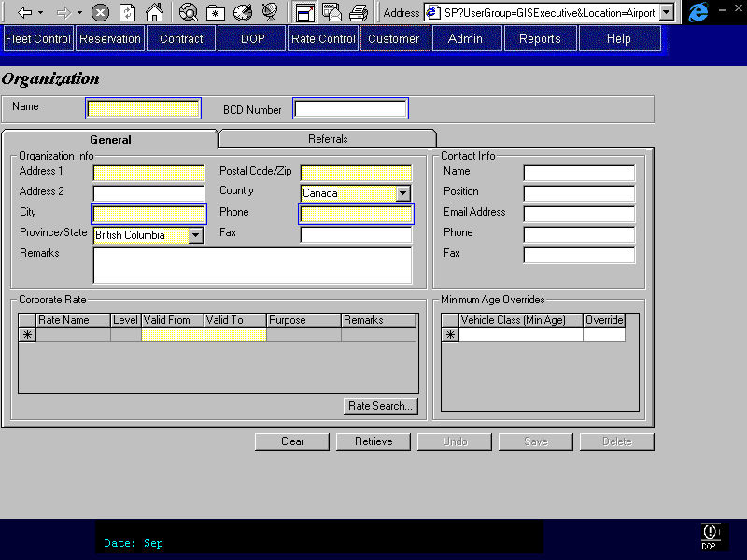

The Organization screen displays and allows editing or creation of organization records for various types of organizations including corporate customers and conventions. General information about these organizations is entered in the General tab and if the organization also refers customers then additional information is entered on the Referrals tab. Organizations can be searched and found by providing an organization name, organization type, BCD number, city or phone number. Note that for city and organization type one of the other searchable fields must also be entered.
Functions
Retrieve: Retrieves a record(s) from the organization table using the information provided in the searchable fields. If multiple records match the search criteria then a search results dialog will display the matching records in a grid. The user will select the desired record and press Select to load the record into the Organization screen.
Save: Insert or update the organization table with a new record or with changes to existing fields. Will also save changes to associated records such as organization rates, commission rates, referring employees and minimum age overrides.
Delete: Sets the inactive flag for the currently displayed organization record in the database. The associated information for referring employees, commission rates, organization rates, and minimum age overrides will remain in the database.
Controls
Field | Source | Req | Validation | Comments
Name | Organization.  Organization | Y
BCD Number | Organization. BCD Number | N | Unique | No wildcards on search

General Tab
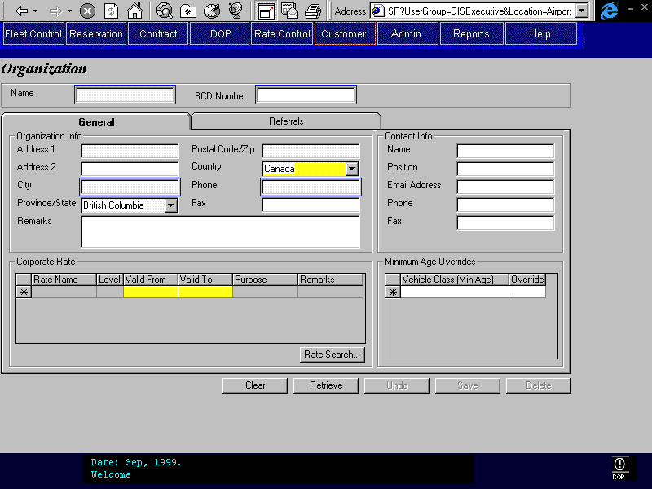
Purpose
The General tab allows for viewing and editing of Organization information. Any Contact information for an organization is entered and maintained on this tab. Existing rates that can be used by the organization can be reviewed and new ones assigned or deleted. This tab also displays the minimum age requirements by vehicle class and allows the user to specify minimum age overrides (exceptions) for the organization.
Navigation
Rate Search: Allows the user to access all available rates and select a rate to assign to the organization.
Controls
Field | Source | Req | Validation | Comments
Address 1 | Organization. Address 1 | Y
Address 2 | Organization. Address 2
City | Organization. City | Y |  | Cannot be used as a search field without Name
Province/State | Organization. Province | S | Controlled by Province/State table. | Required when country is Canada or USA.  updateable
Postal Code/Zip | Organization. Postal Code | S |  | Required when country is Canada or USA.
Country | Organization. Country | Y
Phone | Organization. Phone Number | Y
Fax | Organization. Fax Number | N
Name | Organization. Contact Name | N
Position | Organization. Contact Position | N
Email Address | Organization. Contact Email Address | N
Phone | Organization. Contact Phone Number | N
Fax | Organization. Contact Fax Number | N
Rate Name | Organization Rate.Rate ID | D |  | Display Rate Name.
Rate Level | Organization Rate.Rate Level | D
Valid From | Organization Rate. Organization Rate Valid From | S | >= Vehicle Rate. Valid From | Required when a rate is present.  Default to today or Valid From date, whichever is greater.
Valid To | Organization Rate.Valid To | S | <= Vehicle Rate. Valid To | Required when a rate is present.  Default to Valid To date.
Purpose | Vehicle Rate. Rate Purpose | D
Remarks | Vehicle Rate. Contract Remarks | D
Vehicle Class | Organization Minimum Age Override. Vehicle Class Code | N | Value controlled by Vehicle Class table. | Display Vehicle Class Name.
(Min Age) | Vehicle Class. Minimum Age | D | Not Null | Standard minimum age for class. This is displayed in the along with the vehicle class in the vehicle class selection box.
Override | Organization Minimum Age Override.Minimum Age | S | < Standard >= 18 | Organization’s minimum age override for this class.  Required if Vehicle Class for override is selected.
Technical Notes
Rate records can be deleted from the rate grid by using the keyboard delete key.
Delete will set an inactive flag for the Organization instead of actually deleting the record and it’s children. Subsequent queries of the Organization table will not return these records. GIS will not provide a facility to re-instate an Organization. If Budget wishes to do so a DBA can manually set the inactive flag back to False.
When the screen is populated by a record after a search the grid will display all vehicle classes that have a minimum age override for that organization. Additional overrides may be added by selecting another vehicle class in the bottom line of the grid.

Referrals Tab
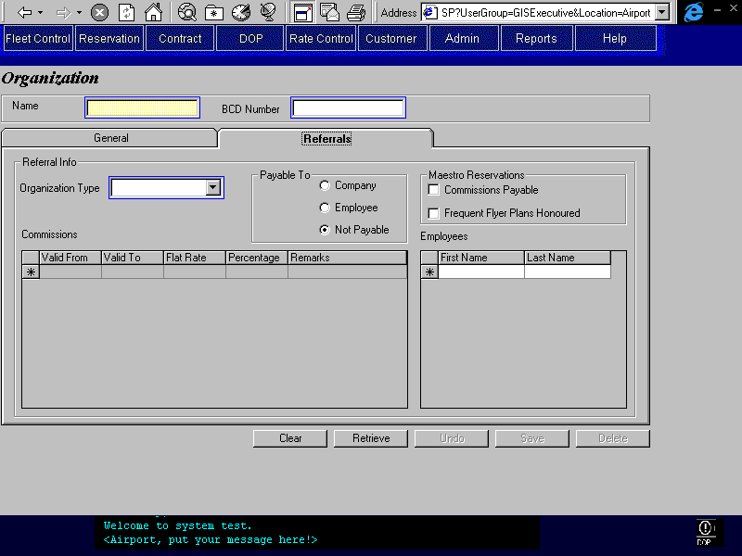
Purpose
Allows the user to view or edit information on organizations that will receive a commission when they refer a customer to Budget. Commissions are payable to either the organization or an employee of the organization. Commissions are valid for a limited time period and are either a fixed amount or a percentage of the rental only revenue (excludes items such as LDW). Organizations can be categorized by type for reporting purposes; these types include bodyshop, hotel, and other.
Navigation
NA
Functions
NA
Controls
Field | Source | Req* | Validation | Comments
Payable To | Organization. Commission Payable | Y |  | Default = Not Payable
Organization Type | Organization. Type |  | Value Controlled by Organization Type Table | Used for reporting purposes
Commissions Grid
Valid From | Commission Rate. Valid From | S | Date Format | Required if commission payable
Valid To | Commission Rate. Valid To | S | >= Commission Start Date, Date Format | Required if commission payable
Flat Rate | Commission Rate. Flat Rate | S | Null when Percentage not Null otherwise > 0 | Either Flat Rate or Percentage required if commission payable
Percentage | Commission Rate. Percentage | S | Null when Flat Rate not Null otherwise > 0 <=100 | Either Flat Rate or Percentage required if commission payable
Remarks | Commission Rate.Remarks | N
Maestro Reservations
Commissions Payable | Organization, Maestro Commission Paid | N
Frequent Flyer Plans Honoured | Organization, Maestro Frequent Flyer Honoured | N
Employees Grid |  |  |  | Employees cannot be deleted if they have been associated with a reservation or a contract (identified in the reservation or the contract as a referring employee).
First Name | Referring Employee. First Name | N
Last Name | Referring Employee. Last Name | N

Organization Search Results Dialog
Purpose
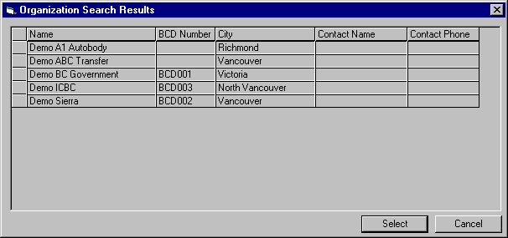
The dialog will display a list of organizations that matched the search criteria a user entered into the Organization screen. The user would select an individual record and press Select or double click on the record to load it into the Organization screen. The user could press Cancel to close the dialog and return to the Organization screen, without loading a record, to perform another search.
Navigation
Select: Closes the dialog and loads the selected record into the Organization screen.
Controls
Field | Source | Req* | Validation | Comments
Name | Organization.Organization | D
BCD Number | Organization.BCD Number | D
City | Organization.City | D
Contact Name | Organization.Contact Name | D
Contact Phone | Organization.Contact Phone Number | D

Customer Screen
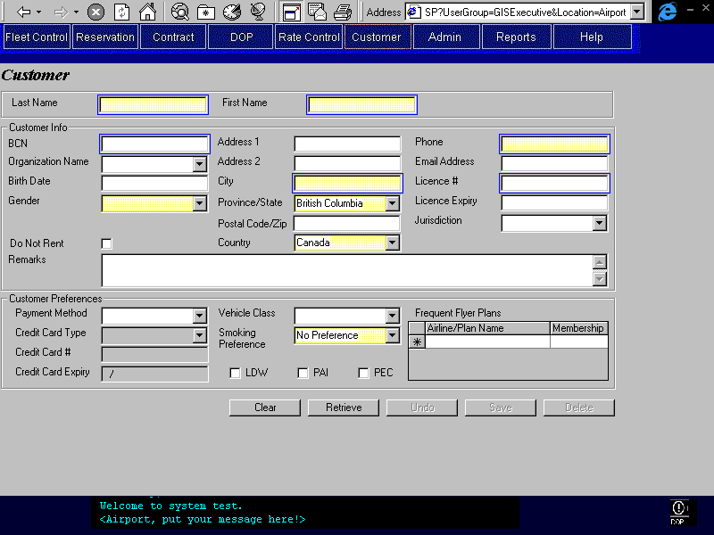
Purpose

The Customer screen displays and allows editing or creation of customers and/or additional drivers’ information including customer name, address, employer’s name, and customer preferences. Users can view and edit customer information using the Customer Screen. Additionally, new records can be made to handle events such as when a blacklisted driver needs to be identified. However, usually new records will be created from a contract check in. Customer preferences reflect information collected from the MRA form, or are captured from the last rental contract made with the individual. Typically, MRA customer information will be captured via the Maestro Interface.

To retrieve a customer record, the user would enter the customer’s first and last name and optionally their BCN (if applicable), city, phone number or driver’s licence number and press Retrieve. If only one record matches the query fields then the form will display that record. If more than one record is retrieved then a search dialog will display a grid with the results. The user would then select the individual record from the grid and press Select and that record would be displayed in the Customer screen.

Navigation
NA
Functions
Retrieve: Perform a search of the customer information in the database based on the search criteria entered by the user. If more than one record matches the search criteria then a search dialog would load with a grid displaying all of the matching entries. The user could then select the individual record from the grid and press Select to load the record into the Customer screen. Note that to control the number of records returned the First and Last Name fields must be entered together, and city must be used in conjunction with other searchable fields.
Save: Insert or update the customer table with a new record or with changes to existing fields. Associated information in the Frequent Flyer Plan Member and Credit Card tables, would also be inserted or updated.
Delete: Logically delete the customer, the customer will still exist on the database but will be flagged as deleted and will no longer be returned in search results.
Controls
Field | Source | Req* | Validation | Comments
Last Name | Customer. Last Name | Y |  | Determines which customer account to search
First Name | Customer. First Name | Y |  | Determines which customer account to search
BCN | Customer. Program Number | N |  | Budget Customer Number
Organization Name | Customer. Organization ID | N | Entry controlled by Organization table. | Display Organization Name.
Birth Date | Customer. Birth Date | N | Date Format
Gender | Customer. Gender | Y | Male or female
Do Not Rent | Customer. Do Not Rent | N | checkbox | Default to not checked
Address 1 | Customer. Address 1 | N
Address 2 | Customer. Address 2 | N
City | Customer. City | Y
Province/State | Customer. Province | S | Controlled by Province/State table. | Required when country is Canada or USA.  Default to British Columbia.
Postal Code/Zip | Customer. Postal Code | S |  | Required when country is Canada or USA
Country | Customer. Country | Y | Controlled by Country table. | Default to Canada
Phone | Customer. Phone Number | Y
Email Address | Customer. Email Address | N
Licence # | Customer. Driver Licence Number | S |  | Required if Licence Expiry or Jurisdiction is not Null.
Licence Expiry | Customer. Driver Licence Expiry | S | Date Format | Required when Licence # not Null
Jurisdiction | Customer. Driver Licence Jurisdiction | S | Value controlled by Jurisdiction table. | Required when Licence # not Null  Default to BC
Remarks | Customer. Remarks | S |  | Required when Do Not Rent is checked
Payment Method | Customer. Payment Method | N | Credit Card, Cash | Default to Credit Card
Credit Card | Customer. Card Type | N | Controlled by Credit Card Type Table | Visa, Mastercard etc.
Card Number | Credit Card, Credit Card Number | N |  | Where Credit Card,Customer ID = current Customer, Customer ID
Card Expiry | Credit Card, Expiry | N | mm/yy e.g. 04/99 0r 10/02 | Where Credit Card,Customer ID = current Customer, Customer ID
Vehicle Class | Customer. Preferred Vehicle Class Code | N | Vehicle Class Table | The vehicle class preferred by the customer
LDW | Customer. Add LDW | N |  | Default to not checked
PAI | Customer. Add PAI | N |  | Default to not checked
PEC | Customer. Add PEC | N |  | Default to not checked
Smoking Preference | Customer. Smoking/Non-Smoking | Y | Either Smoking, Non/Smoking, or No Preference | Default to No Preference
Frequent Flyer Plans Grid
Airline/Plan Name | Frequent Flyer Plan Member. Frequent Flyer Plan ID | S | Airline Table | Display name of Airline concatenated with Frequent Flyer Plan Name (from Frequent Flyer Plan table). Required if Membership is entered.
Membership | Frequent Flyer Plan Member. Frequent Flyer Member Number | S |  | Membership number. Required if Airline/Plan is entered.

Renter Information
This section consolidated into main screen section (above) since tabs are no longer required due to the removal of renter history. Decision January 25, 1999.

Rental History Tab
No longer required. Decision January 25, 1999.

Customer Search Results Dialog
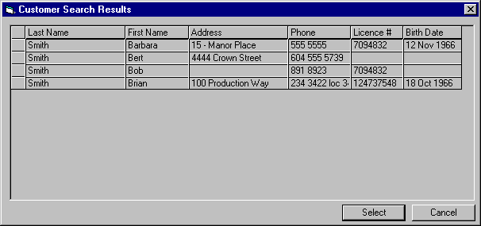
Purpose
The dialog will display a list of customers that matched the search criteria a user entered into the Customer screen. The user would select an individual record and press Select or double click on the record to load it into the Customer screen. The user could press Cancel to close the dialog and return to the Customer screen, without loading a record, to perform another search.
Navigation
Select: Closes the dialog and loads the selected record into the Customer screen.
Controls
Field | Source | Req* | Validation | Comments
Last Name | Customer. Last Name | D
First Name | Customer. First Name | D
Address | Customer.Address 1 | D
Phone | Customer.Phone Number | D
Licence # | Customer.Driver Licence Number | D
Birth Date | Customer.Birth Date | D

Reports
Reports to be designed by Budget personnel at a future date.

Do Not Rent List

Frequent Renter List

Referral Organizations by Organization Type

Background Processes
There are no background processes for Customer Profile.

Test Scenario List
- Create a new Organization.
- Add a new rate to the organization.
- Add a new minimum age override to the organization
- Add referral information to the organization:
- Add a commission rate
- Add an employee(s)
- Set the referral organization Payable to field to Employee
- Set the Organization Type to bodyshop.
- Save the newly created organization.
- Search for an existing organization using:
- Name
- BCD Number
- City and Phone Number
- Name, City, and Phone Number
- Edit an existing organization.
- Add and delete a rate
- Add, edit, and delete a minimum age override
- Edit the Organization and Contact Information
- Add, Edit and Delete a commission rate
- Add, Edit and Delete an employee
- Create a new Customer
- Add a frequent flyer plan to the customer.
- Set the customer preferences
- Save the new Customer
- Create a new customer from a reservation (First Name, Last Name, and Phone #)
- Search for an existing Customer using:
- Last Name and First Name
- BCN
- City and Phone
- Driver’s Licence Number
- Edit an existing Customer
- Edit customer information and save
- Add, Edit, and Delete a frequent flyer plan
- Edit the Credit card and customer preferences information
- View a customers Rental History
- Update a customer’s preferences automatically at Contract Close

Controls & Audit Trails
Object | Type | Fields
Organization | Screen | Last Modified By, Timestamp
General | Tab | None
Referral Organization | Tab | None
Organization Search Results | Dialog | None
Customer | Screen | Last Modified By, Timestamp
Renter/Additional Driver | Tab | None
Rental History | Tab | None
Customer Search Results | Dialog | None
Do Not Rent List | Report | None
Frequent Renter List | Report | None
Referral Organizations by Organization Type | Report | None

Security Requirements
The following table shows an initial breakdown of system objects and the permissions allowed to groups accessing those objects.
 – Full access to object. I – Inquiry access only to object.
Object | Type | Exec-utive | Info Systems | Reserva-tions | Customer Service | CSR
Organization | Screen |  | I | I | I | I
General | Tab |  | I | I | I | I
Referral Organization | Tab |  | I | I | I | I
Organization Search Results | Dialog |  | I | I | I | I
Customer | Screen |  | I | I | I | I
Renter/Additional Driver | Tab |  | I | I | I | I
Rental History | Tab |  | I | I | I | I
Customer Search Results | Dialog |  | I | I | I | I
Do Not Rent List | Report |  |  |  | 
Frequent Renter List | Report | 
Referral Organizations by Organization Type | Report | 

The final security requirements will be defined in the Security Business Design.

Business Transaction Volumes
Budget anticipates the volume for the Customer profile screens to be very low. Approximately 10,000 new customers could be added each year but most of these will be added through a contract and not using the Customer screen. The number of new Organizations that will be added will also be extremely low.
The transaction volumes for the Customer profile functions will be minimal and alone, should not place any undue stress on the GIS system in terms of limiting performance or throughput.

Tables without Maintenance Screens
This section has been superseded by the Production System Maintained Files document.
- Organzation Type (for Referral Organizations)
- Hotel
- Body Shop
- Province/State
- All Canadian provinces and territories
- All American states.
- Gender
- Female
- Male

- Jurisdiction
- All Canadian provinces and territories

System Values Table Entries
None.

Data Model

Revision History

Version 2.00
- Clean up documentation and make consistent with the GIS standards.

